# Appointment Tracker

Contents

Appointment Tracker 1

Story 1

Post Installation Instructions 3

Troubleshooting 4

Widget not visible in community 4

Widget visible but no appointments displayed 4

## Story

Appointment tracker display list of appointments (Event records) for logged user.

List is displaying two modes controlled by button in header

1. Current and Future Appointments (default)

**ActivityDate**>=*TODAY*

1. Historical appointments (limit set to 100 records and controlled in APEX class) recent first

**ActivityDate**<*TODAY*

**Required:** Event records displayed in Community must have Flag **Public** (Event.IsVisibleInSelfService) on Event record set to true. This is maintained using **Event_Before.trigger** for non standard user license types. If you want to use it for standard users you will need to modify trigger.

**if** (UserInfo.*getUserType*()!=**'Standard'**) Obj.**IsVisibleInSelfService**=**true**;

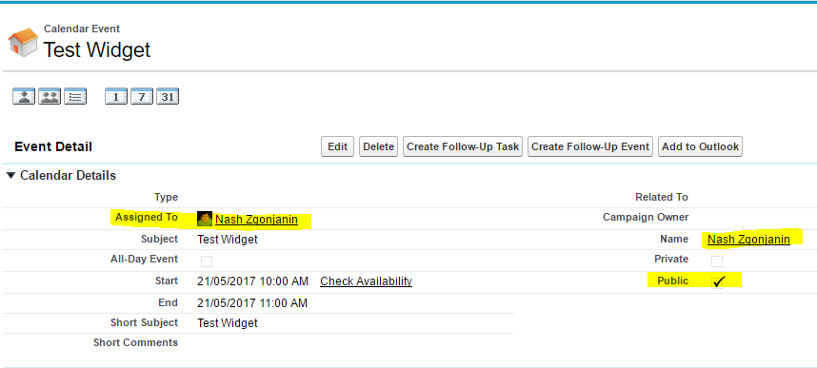

**VisualForce Page**, **APEX controller** and **SLDS** are used to run Appointment Tracker in lightening or Community builders using VisualForce component.

This widget assumes that AssignedTo (Event.OwnerId) give service to client/Contact (Event.WhoId). When contact log to community he will see appointments. Advisor can use standard Lightening calendar to see his appointments in calendar view.

Widget is responsive and will fit any space that you want to use on lightening page.

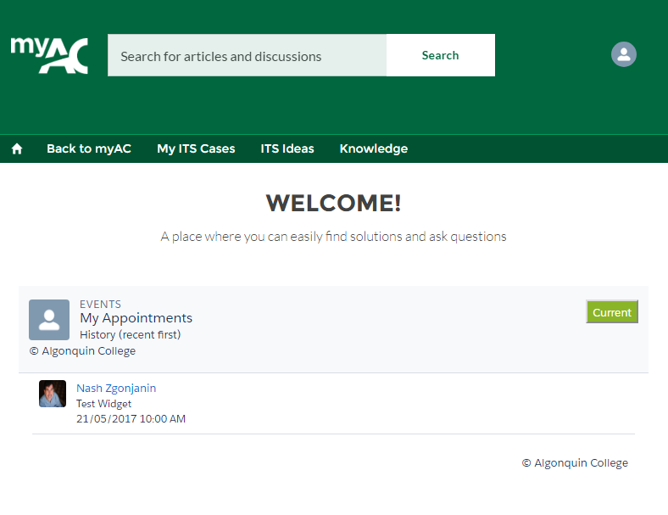

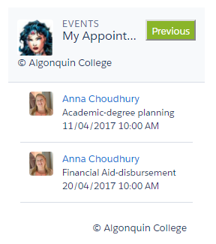

## Post Installation Instructions

After installation, you need to do security setting for APEX class and VisualForce page for every profile that will use widget.

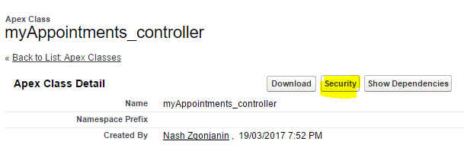

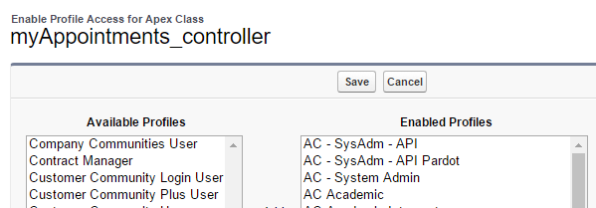

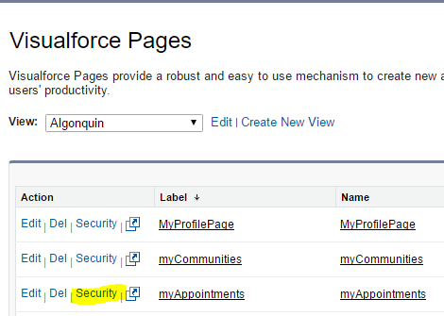

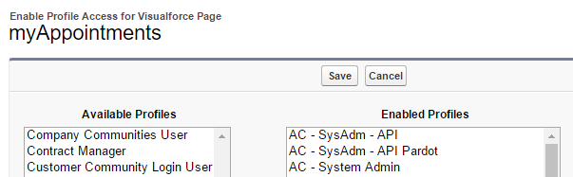

## Troubleshooting

### Widget not visible in community

You didn’t set security on Controller and Visual Force page for user profile that is logged in community.

You didn’t set security on Event Object and Event object field security for fields needed to be visible in for user profile that is logged in community.

### Widget visible but no appointments displayed

EVENT Object Field level security for fields need to be set **Read Access** for fields.

**SELECT Id**, **WhoId**, **WhatId**, **Subject**, **Location**,  
 **StartDateTime**, **EndDateTime**,  
 **Description**,  
 **IsVisibleInSelfService**, **IsPrivate**, **ActivityDate**, **OwnerId**,  
 **Owner**.**Name  
FROM** Event

Field Public must be set true for every event record that you want to display in community. Trigger does this on insert for every event record created by user that is non standard type. To use wodget with standard type of license you will need to modify trigger to support your objectives.

**if** (UserInfo.*getUserType*()!=**'Standard'**) Obj.**IsVisibleInSelfService**=**true**;

